EVEN RSA CAN BE BROKEN
Langkah langkah
Launch instance kemudian didapatkan nc verbal-sleep.picoctf.net 65099
Dan run di terminal 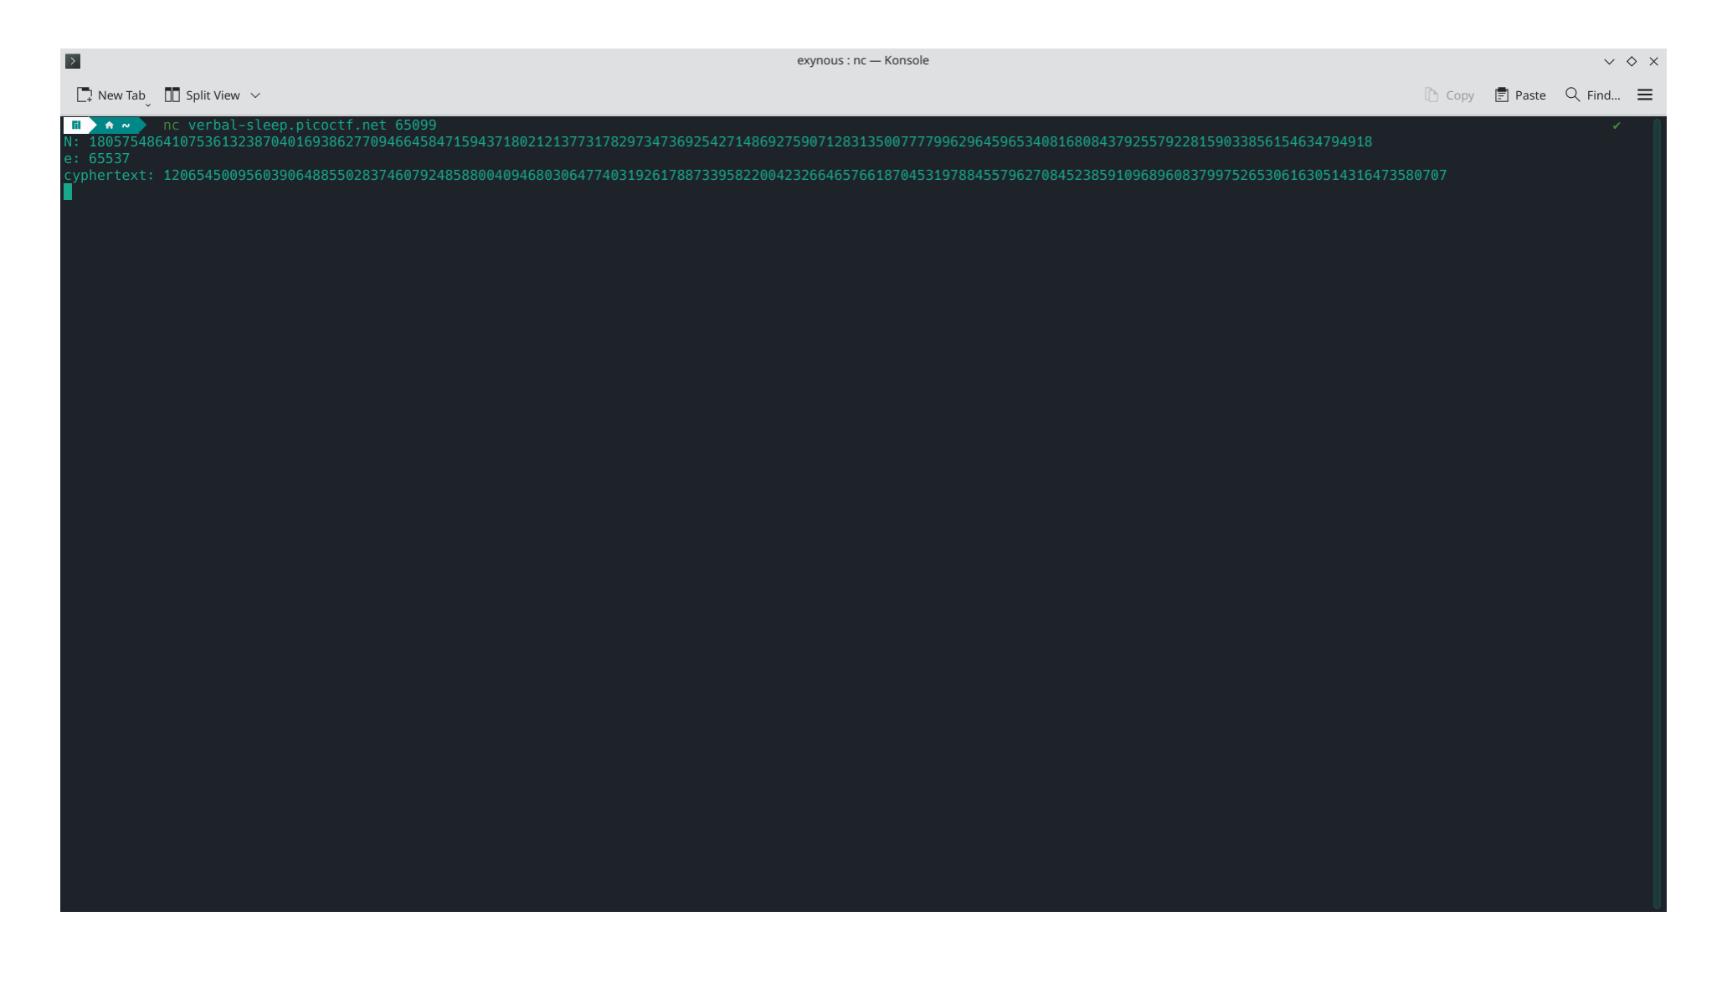
Didapatkan kode ciphertext hasil enkripsi RSA
N (modulus) = 18057548641075361323870401693862770946645847159437180212137731782973473692542714869275907128313500777799629645965340816808437925579228159033856154634794918
e (public exponent) = 65537
ciphertext = 12065450095603906488550283746079248588004094680306477403192617887339582200423266465766187045319788455796270845238591096896083799752653061630514316473580707
Lalu proses menggunakan tools
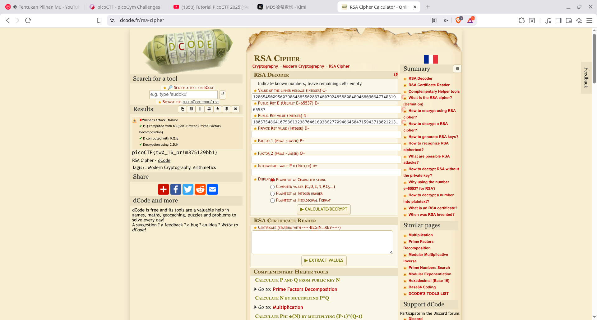
Dan didapatkan flag nya yaitu
picoCTF{tw0_1$_pr!m375129bb1}

